Section: 17595 Room: NEA 203 Day/Time: T/Th 10:35 a.m. – 12:00 p.m.
ENGLISH 101: COLLEGE READING AND COMPOSITION
Our class support site is located at:
www.profsavard.weebly.com
This site has digital resources such as the class syllabus, essay assignments, rubric info, grammar help, learning aids, fun links, and more. If you are confused about something, or have lost an important class documents, everything is archived here for download.

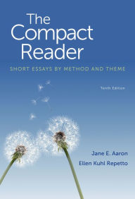

Hello! I’m Professor Savard.
Welcome to my class.
Please visit me at my office during visit times listed below. Drop by for help or advice, or just to say hi.

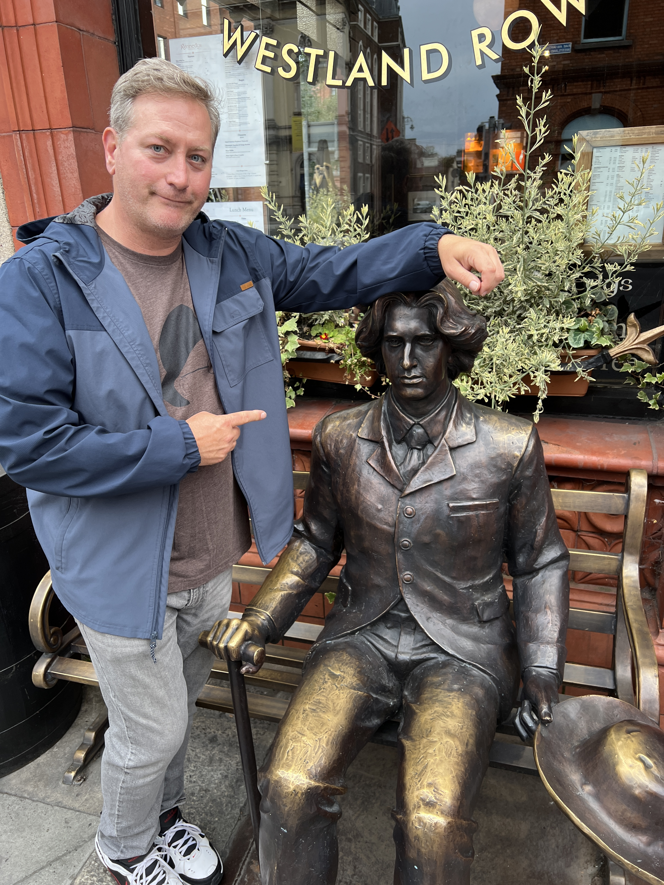

Office Location: NEA 271
Meeting Times: T/TH 12-1 p.m. or by appointment. If these times don’t work, let me know. We can make a special appointment time. You can always email me at savardhe@lahc.edu

Hello! I’m Professor Savard.
Welcome to my class.
Please come visit me at my office during student visit times listed below. Drop by for help or advice, or just to say hi.

Office Location: NEA 271
Meeting Times:T/Th 10-11 a.m. and 12:45-1:30 p.m. If these times don’t work for you please let me know. We can make a special appointment time. You can always email me at savardh@lahc.edu

The Compact Reader 10th edition, by Aaron and Repetto ISBN# 978-1-457-63297-6

Fast Food Nation,
by Eric Schlosser
(Any edition will do, paperback, hardback, etc.)

Highly Recommended:
- A personal computer
- Internet access
- Email
- Calendar
- Priorities
- Common Sense
- Responsibility
- Sense of humor

Teaching Philosophy:
I believe that each student has the potential to succeed in my class. I support my students as individuals. I listen to my students and their needs. I try to develop a "mentor" relationship with my students, which means that I’m no better than you, but I just have more experience and expertise in English. I barely passed my freshman English 101 class. As the first one in my family to go to college, I had no idea what I was getting myself into. You probably don’t either, but that’s where I come in. If you are willing to work hard, try new strategies, be flexible, and commit to your goals you can be successful in this class and in college.

Course Description: Welcome to English 101. This composition course will help you develop the reading, critical thinking, and writing strategies necessary for success in college-level composition. We will examine varied text selections and types and will write both informal and formal pieces. We will spend class time evaluating assigned readings, discussing the experiences of composing, and sharing texts and opinions. There will be both at-home and in-class writings, all of which will factor into your final grade. Grammar exercises, journaling, peer editing, spontaneous writing practice, and self-evaluations will supplement our formal essay writing. Prerequisite: Acceptable score on the placement test, English 28 or equivalent with a grade of “C” or better.
Student Learning Outcomes (by the end of this course you will):
- Apply critical reading and thinking skills to various freshman composition level readings including essays and the novel.
- Write freshman-level essays that follow the various stages of essay writing, including prewriting, thesis development, illustration and support of the thesis using concrete, specific evidence/examples, editing, proofreading and which are free of most errors in syntax, grammar, punctuation, diction, and spelling, and which demonstrate understanding of effective college-level argumentation by producing logically supported arguments and by recognizing and avoiding common logical fallacies.
- Produce a research paper which utilizes the various elements of research production, such as designing a research plan, compiling research notes, developing a draft, producing a finished paper that utilizes at least five sources and has a complete MLA-format Works Cited page.

How to be Successful in this Class:

Attendance: Attendance is mandatory to pass this course. You must attend all classes and be on time. You are allowed two absences, no questions asked. If you know ahead of time that you will be late or absent on a specific day let me know; this may excuse your tardy or absence. Continued absences or tardiness--regardless of reasons--will adversely affect your grade. Please note that if your absences in “hours” exceed the number of hours the class meets per week, you may be dropped from the class. This class meets 3 hours per week.

Classroom Etiquette:
Respect should be given to your peers and instructor at all times. Treat others as you would like to be treated. Arrive to class on time and stay the entire period. Turn off all cellular phones and sound-emitting electronics upon entering the classroom, unless otherwise given permission. Students may not record audio or video in this class except in accordance with ADA accommodations. Any recordings made in connection with a disability accommodation are for the student’s personal academic use only and may not be distributed in any manner to any other individual.
Study Skills:
Embrace questioning and inquiry, and realize you don’t know everything, but you should. It’s a tough world out there. Remember that you probably know a great deal already—try to access this information at all times. Follow directions to the best of your ability. The amount of work you will do in this class, and many other college classes, is far more demanding than what you think it will be. Assume that you will need to read everything at least three times: once just to figure out what it is, twice to deal with the vocabulary and strangeness, thrice to start to identify some meaning and structure, and on…To this end you, you must annotate your readings. Write in Your Books! Take Notes! Create Questions! The road to success in this class and in life is asking the right questions. Make yourself into that annoying five-year old who constantly says, “But why?”

How Your Grade is Calculated:

Participation: Participation is calculated by your attendance in class, preparedness, and your support of the classroom environment. It is a vital component of this class, as most of our time will be spent discussing in class the readings and concepts related to them. Since participation accounts for a hefty chunk of your final grade, I advise you to read actively, jotting down specific questions, reactions, and observations in regards to the texts. You will thus be better prepared to discuss the works in class. It is usually necessary to read an author’s essay at least twice. Additionally, throughout the semester, we will divide ourselves into working groups. The groups will meet in class to tackle grammar exercises or discuss the readings and share and compare observations with the other groups and the professor. Finally, please bring your books, notes, and materials to class every day.

Course Work: All work is due at the beginning of class the day the assignment is listed on the class schedule. If you fail to turn in an assignment on its due date, your final grade for the assignment will be marked down three full grades for each class day that it is late. This rule applies to all out of class work. There are no make-ups for reading quizzes or any other work done in class. I do not accept any work via email.

Reading Quizzes: Expect to read regularly. You will be quizzed on readings. Quizzes may not be made up. Each quiz is worth 10 points and is open-book, open-note.

Reading and Writing Exercises: We will do many in-class reading, writing, and grammar assignments, which correspond to the assigned reading for that day—these are worth 10 points.

Journals: For each essay we read in The Compact Reader first answer the “Journal Response” questions at the beginning of the essay; next, answer the “Meaning” questions at the end of each essay. Handwrite your responses. Your responses will vary in length, but should be about one page total for each group of questions. For each chapter we read in Fast Food Nation write at least one page of reactions/notes/thoughts about the chapter. The journals are due the day we discuss the essay or reading in class. Note that you are not required to answer any other reading questions.
Essays: Students are required to write three out-of-class essays of varying lengths. Since we will concern ourselves not only with final products, but also with the writing process itself, you will be required to complete prewriting activities and write successive drafts of all out-of-class essays. Further details when essays are assigned. Your class final is an in-class essay.
Additionally, there is a research paper between 6 and 8 pages. This research essay will prepare you to succeed in any class you take in the future. It is the capstone of the semester and should be taken seriously. We will do research activities and prewriting leading up to the final submission, all of which will be part of the 250 point total. You will have individual help. You can do it!
Essays are graded using a rubric. We will discuss and analyze this rubric in great detail throughout the semester. The elements of the rubric are:
1) Thesis, Process, and Response to Prompt
2) Content Development, Support, and Organization
3) Coherence, Style, and Voice
4) Grammatical soundness (usage, sentence structure, punctuation, spelling, etc.).
5) Critical, Evaluative, and Analytical Elements

You must turn in all outside essays (3) in order to pass this course.

Additionally we will be using Turnitin.com to submit all out-of-class essays. Every essay must be submitted to Turnitin.com by the start of class on the date the essay is due and a final hard copy must be brought to class and turned in. You must do both to turn in an essay properly for a grade. Directions for registration are:
1) Go to http://www.turnitin.com
2) Click on “create an account” and then follow the hyperlink for “student.” (If you have
previously used Turnitin, you can log in with your prior information.)
3) Enter class ID and password: Class ID 42602922 Enrollment key: write
4) Continue with all registration prompts and find your class and section: Eng 101 Spring 2024

 |  |  |  |  |  |  |  |  |  |  | Your Total  Points | Points  Possible
Quizzes  10 points each |  |  |  |  |  |  |  |  |  |  |  | 100
R & W Ex.  10 points each |  |  |  |  |  |  |  |  |  |  |  | 100
Journals  10 points each |  |  |  |  |  |  |  |  |  |  |  | 100
Journals  10 points each |  |  |  |  |  |  |  |  |  |  |  | 100
Essays  100 points each |  |  |  |  |  |  |  |  |  |  |  | 300
Final Essay  250 points |  |  |  |  |  |  |  |  |  |  |  | 250
Notes: Final essay includes Proposal (25), Round table (25), Annotated Bibliography (50), and Research essay (150) = 250 points total  Total Points |  |  |  |  |  |  |  |  |  |  | Participation | 50
 |  |  |  |  |  |  |  |  |  |  |  | 1000

How is Your Grade Calculated?
The grading scale for this class is:
90% (900 points) and above = A
80%-89% (800 to 894) = B
70%-79% (700 to 794) = C
60%-69% (600 to 694) = D
59% (590) and below = F

To calculate your grade at any time, simply divide your total points by the total points possible. For example:
900 ÷ 1000 = 90% or an A!
450 ÷ 500 = 90% also an A!

Other Information:
Emergency Procedures: If required to evacuate a classroom or building, students will proceed to a clear and safe area away from the building. Take all personal belongings with you.
Academic Accommodations: Students with verified disabilities requiring accommodations should make a specific request of the instructor in a timely manner, both at the beginning of the semester and at least one week prior to the verified and identified need.
Academic Integrity: Plagiarism occurs when you copy someone else’s words, work, or ideas and pretend that they are your own. Academic dishonesty is a serious offense that carries with it heavy penalties. The bare minimum in terms of punishment for plagiarism is an ‘F’ on the assignment and a referral to the dean. Other penalties include academic probation and expulsion from Los Angeles Harbor College. Such things tend not to enhance one’s resume/application for either a job or college. For further information, refer to the Los Angeles Harbor College catalog. It is essential that you read and fully understand this statement.
Commitment to Viewpoint Diversity, Mutual Understanding, & Constructive Disagreement
In order to create a classroom environment that supports respectful, critical inquiry through the free exchange of ideas, the following principles will guide our work:
• Treat every member of the class with respect, even if you disagree with their opinion;
• Bring light, not heat;
• Reasonable minds can differ on any number of perspectives, opinions, and conclusions;
• Because constructive disagreement sharpens thinking, deepens understanding, and reveals
novel insights, it is not just encouraged, it is expected;
• All viewpoints are welcome;
• No ideas are immune from scrutiny and debate;
• You will not be graded on your opinions.
Syllabus Changes: The professor reserves the right to make any changes to this syllabus as necessary. If any changes are made, the students will be notified promptly, and sufficient time will be given to adjust to the changes. This syllabus is a contract, and if you remain in this class, you are agreeing to abide by its rules and regulations. This applies to the instructor as well.
Finally: If you have a problem, question, or concern with anything on this syllabus or in this class, please come talk to me! I assure you that approaching me for help or clarification will prove beneficial. My office is in NEA 271, phone extension is 4241, email is savardhe@lahc.edu
CLASS CONTACTS
Name: ________________________________________________
Phone #: ______________________________________________
Email: ________________________________________________

Name: ________________________________________________
Phone #: ______________________________________________
Email: ________________________________________________

Name: ________________________________________________
Phone #: ______________________________________________
Email: ________________________________________________

Date | Topics & Reading Due (finish before class) | Homework Due or In-Class Assessment | Objectives & Notes
Tue  2/6 | Syllabus, Introductions
Thu 2/8 | The Compact Reader (TCR) Chapter 1 | R&W Exercise on “Shacks” Reading strategies, and MLA format
Tue  2/13 | TCR Chapter 2, 3, 4 | R&W Exercise | Essay #1
Thu  2/15 | The Nature of Argument and Critical Thinking | R&W Exercise | Classic Appeals
Tue  2/20 | TCR Chapter 8 | Quiz  Journal Due
Thu  2/22 | TCR Chapter 9 | Quiz  Journal Due
Tue  2/27 | NO CLASS | NO CLASS
Thu  2/29 | TCR Chapter 11 | Quiz  Journal Due
Tue  3/5 | Rough Draft of Essay #1 due | Bring one typed copy, all prewriting, and outline to class. R&W Exercise | Assignment of Essay #2
Thu  3/7 | Essay #1 due | Staple hard copy to rough draft, prewriting, and outline. Submit final draft to Turnitin.com
Tue  3/12 | Library Visit  TCR 384-411  Using sources | R&W Exercise
Thu  3/14 | TCR Chapter 12 | Quiz  Journal Due
Tue  3/19 | TCR Chapter 13 | Quiz  Journal Due
Thu  3/21 | Readings as assigned | RW Exercise
Tue  3/26 | Rough Draft of Essay #2 due | Bring one typed copy, all prewriting, and outline to class R&W Exercise
Thu  3/28 | Essay #2 Due | Staple hard copy to rough draft, prewriting, and outline. Submit final draft to Turnitin.com | Final Research Paper Assigned
Tue  4/2 | SPRING BREAK | NO CLASS!!!
Thu  4/4 | SPRING BREAK | NO CLASS!!!
Tue  4/9 | Fast Food Nation Introduction, and Chapter 1 | Quiz Journal Due
Thu  4/11 | Fast Food Nation  Reading
Tue  4/16 | FFN Ch. 1, 2, 3 | Quiz Journal Due | Assignment of Fast Food Nation Project (essay#3)
Thu  4/18 | FFN Ch. 4, 5 | Quiz Journal Due
Tue  4/23 | FFN Review | Quiz Journal Due | Assignment of Food Cost Calculator
Thu  4/25 | FFN Ch. 6 | Quiz Journal Due
Tue  4/30 | FFN Ch. 7 | Quiz Journal Due
Thu  5/2 | FFN Ch. 8 | Quiz Journal Due
Tue  5/7 | FFN Ch. 9 | Quiz Journal Due
Thu  5/9 | FFN Ch. 10 | Quiz Journal Due
Tue  5/14 | FFN Epilogue, Afterword
Thu  5/16 | Review
Tue  5/21 | Food Cost Calculator Assignment Due
Thu  5/23 | Fast Food Nation Project Due (as Essay #3). | Fast Food Nation Journals due
Thu  5/30 | Class Final  10:00 am-12:00 pm | Final Assignment. Papers returned. Grades given. Be here.

